Hardware Requirement:

* NODEMCU (12-E)
* PUSH BUTTON
* OLED DISPLAY
* Jumper Wires

Software Requirement:

* ARDUINO IDE
* WEB APP
* JAVA SCRIPT
* WEATHER API

Block Diagram: (Circuitry Format)

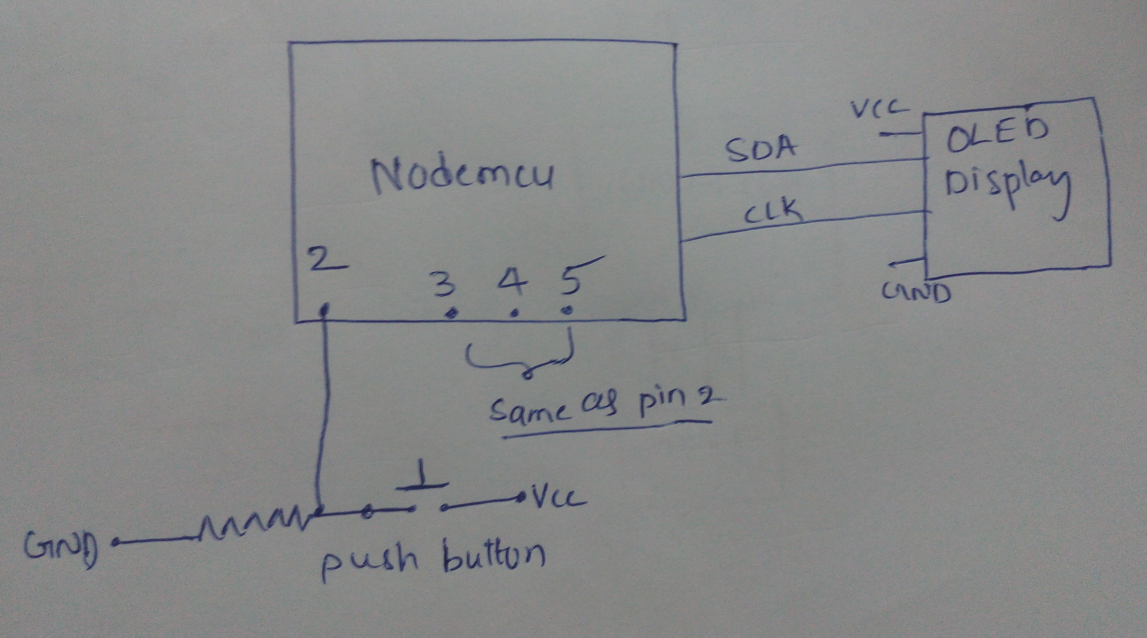

Project Highlights:

* Interfacing Sensors
* Uploading sensors data to clod
* Retrieving data from cloud

Project Description: About the best features of the projects and something about the architecture.

In present Systems the road signs and the speed limits are Static. But the

road signs can be changed in some cases. We can consider some cases when

there are some road diversions due to heavy traffic or due to accidents then we

can change the road signs accordingly if they are digitalized.

What will you learn: (Technology):

* Microcontroller programming
* Sensors interfacing
* Cloud technology
* Designing an web app

Pictures & Video

Project Title**: Smart connected Signs for Improved Road Safety**